Walkthrough 24 Filtering

<https://sapui5.hana.ondemand.com/#/topic/5295470d7eee46c1898ee46c1b9ad763>

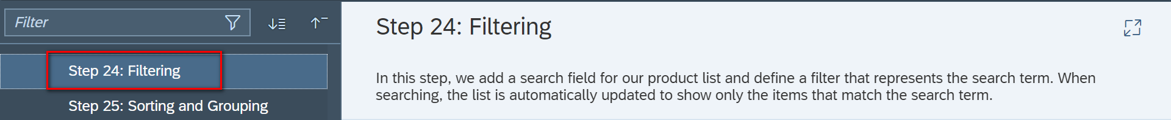

Core Changed Codes Compared to Last Version:

InvoiceList.view.xml:为发票列表增加ID以及全局搜索过滤器,并为执行查询动作分配处理方法onFilterInvoices

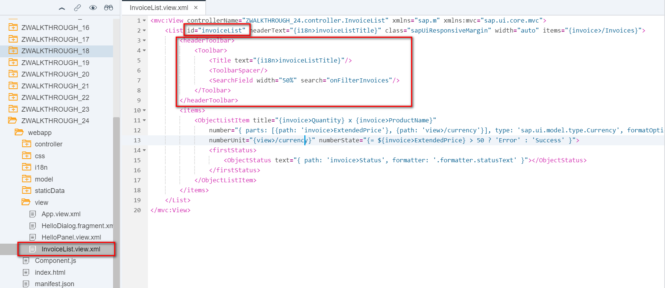

InvoiceList.controller.js:实现搜索功能【对于产品名称内容的模糊搜索】

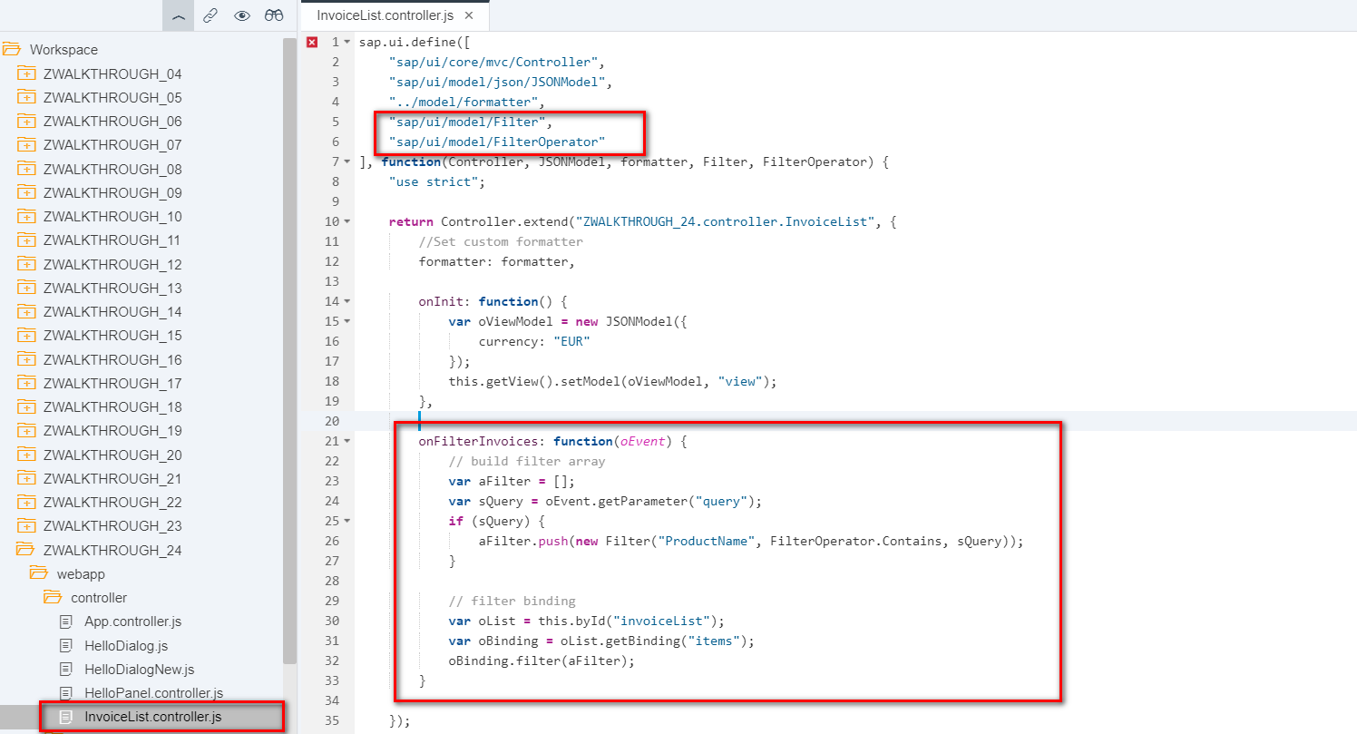

i18n 文本对象管理

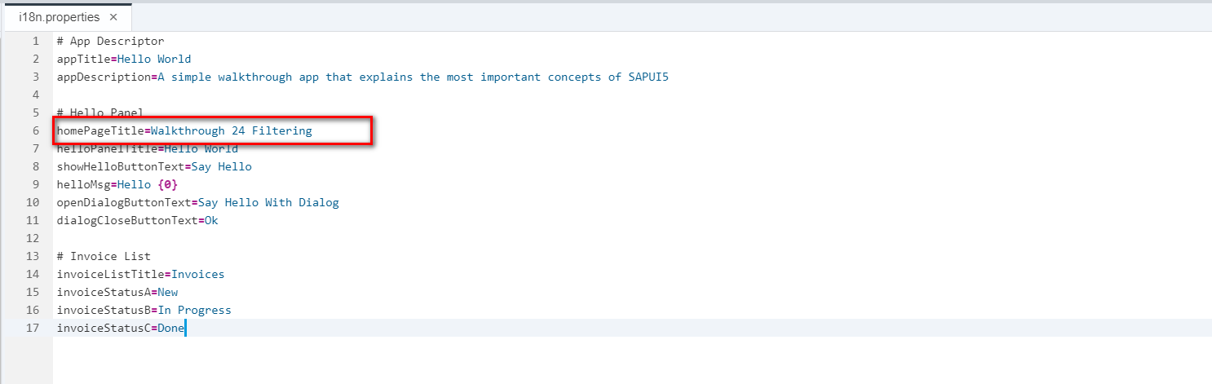

Result

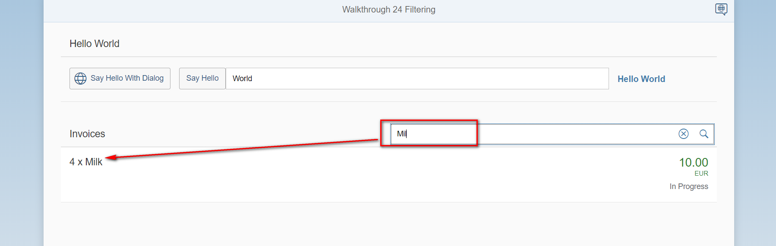

Git:

https://github.com/xiexiaop/SAPUI5-2-Round/tree/master/Projects/ZWALKTHROUGH_24

2019/02/04 XiaoMi Beijing Zac,Xie